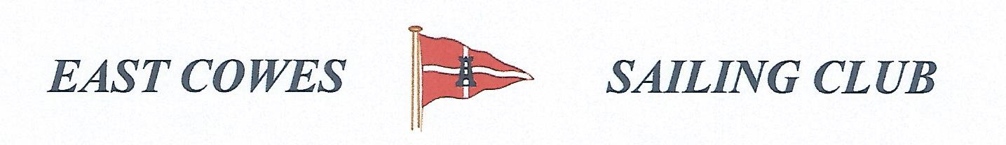 HEAVIEST BREAM COMPETITION
SATURDAY 23rd JULY 2022
Weather Permitting
High Tide 0815, Low tide 14.00(Approx)
2 rods per person allowed ; No entrance fee
Start fishing from 0830, Weigh in 16.00 0utside the club house for heaviest Bream.
Hammer head required late afternoon and evening of 23rd July.
Please inform Ray Hallett Rear Commodore Motor Boats & Fishing email: motor@eastcowessc.co.uk Mobile: 07815 579289
Or Mike Harvey 07443289170
