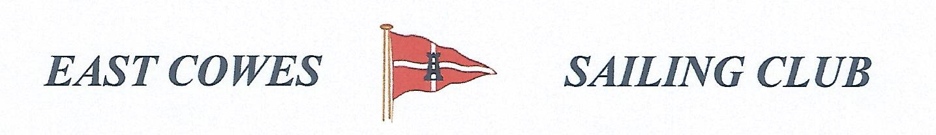 HEAVIEST BREAM COMPETITION
SUNDAY 24th JULY 2022
Weather Permitting
High Tide 0915, Low tide 15.00(Approx)
2 rods per person allowed ; No entrance fee
Start fishing from 0800, Weigh in 16.00 0utside the club house for heaviest Bream.
Hammer head required late afternoon and evening of 24th July.
Please inform Ray Hallett Rear Commodore Motor Boats & Fishing email: motor@eastcowessc.co.uk Mobile: 07815 579289
Or Mike Harvey 07443289170
