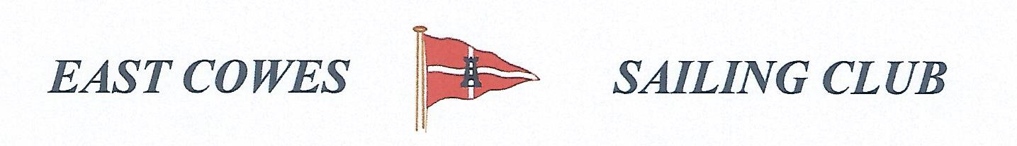 HEAVIEST BASS COMPETITION
SUNDAY 19th June 2022
Weather Permitting
High Tide 1647, Low tide 11.00(Approx)
2 rods per person allowed ; No entrance fee
Start fishing from 0800, Weigh in 17.00 0utside the club house for heaviest Bass.
Hammer head required late afternoon and evening of 18th June.
Please inform Ray Hallett Rear Commodore Motor Boats & Fishing email: motor@eastcowessc.co.uk Mobile: 07815 579289
Or Mike Harvey 07443289170
