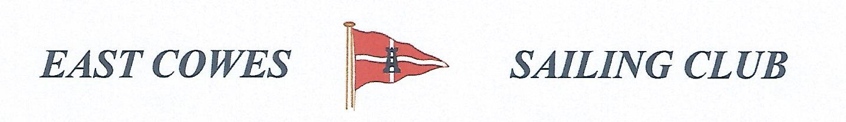 HEAVIEST RAY/SKATE COMPETITION
SUNDAY 24th April 2022
Weather Permitting
High Tide 0625 a.m, Low tide 12.25(Approx)
2 rods per person allowed ; No entrance fee
Start fishing from 0800, Weigh in 17.00 0utside the club house for heaviest Ray/Skate.
Hammer head required late afternoon and evening of 23rd April
Please inform Ray Hallett Rear Commodore Motor Boats & Fishing email: motor@eastcowessc.co.uk Mobile: 07815 579289
Or Mike Harvey 07443289170

