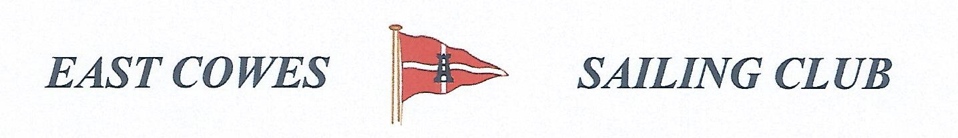 HEAVIEST FISH COMPETITION
SUNDAY 16th January 2022
Weather Permitting
High Tide 10.30 a.m, Low tide 16:30(Approx)
2 rods per person allowed ; No entrance fee
Start fishing from 0800, Weigh in 16.00 0utside the club house for heaviest Fish.
Hammer head required late afternoon and evening of 16th January
Please inform Ray Hallett Rear Commodore Motor Boats & Fishing email: motor@eastcowessc.co.uk Mobile: 07815 579289
Or Mike Harvey 07443289170
