Report on heaviest Cod competition November 14th 2021
This was a rescheduled competition, as the competition due at the end of October was cancelled due to bad weather.
Only three boats with four people ventured out on a what begun a day with a chilly northerly breeze. Mike and Richard fisher off the Bramble bank and caught mainly whiting (see below), and congers, although Richard caught two good sized Bass. No record of what Phill and Bob caught in their Avor, but I saw them come back.

The next competition will for the heaviest Fish and Cod on November 28th .

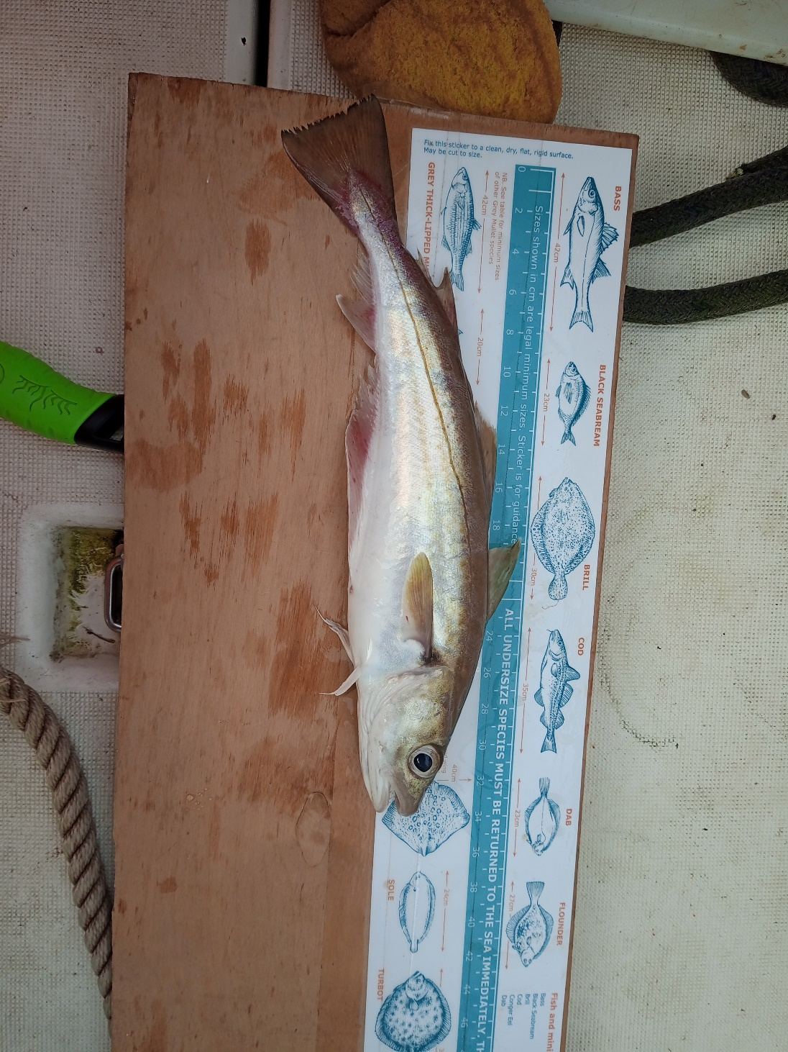

Cheers Mike and Ray

