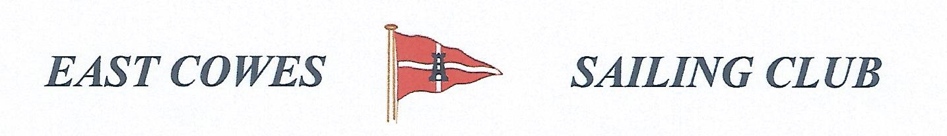 HEAVIEST FISH AND HEAVIEST COD COMPETITION
SUNDAY 28th November 2021
Weather Permitting
High Tide 0530 a.m, 1750 Low tide 11:30 a.m(Approx)
2 rods per person allowed ; No entrance fee
Start fishing from 0800, Weigh in 16.00 0utside the club house for heaviest Cod.
Hammer head required late afternoon and evening of 27th November and 28th November
Please inform Ray Hallett Rear Commodore Motor Boats & Fishing email: motor@eastcowessc.co.uk Mobile: 07815 579289
Or Mike Harvey 07443289170
