Report on biggest Bass competition June 6th 2021
What a great competition, with 10 boats and 16 people. The weather was also kind with a gentle breeze and sunny in the afternoon. Most boats fished of the Prince Consort buoy for a time where a lot of Bass were caught. Other boats went to Ryde West Middle, Bramble bank and Thorness Bay.
Three boats were visited by the bass police, who were checking on bass sizes caught (legal limit 42 cm and over). Richard also spent time watching Elvis in a western film.
Bass were caught by four boats and 7 people. The biggest bass was 46cm, caught by Sam Legg on Herbies boat, who attained 16 points towards the end of season cup; This was followed by Iain Molyneaux with a bass of 43 cm, gaining 15 points, next followed by Tim, 14 points and his brother 13 points. Other points were shared by 3 other people, Herbie with 12 points, Iain’s brother, John, with 11 points and Mike with 10 points. This point system should be reviewed at the next fishing meeting.
The next competition will be in July 4th for the heaviest Bream.

Cheers Richard and Mike
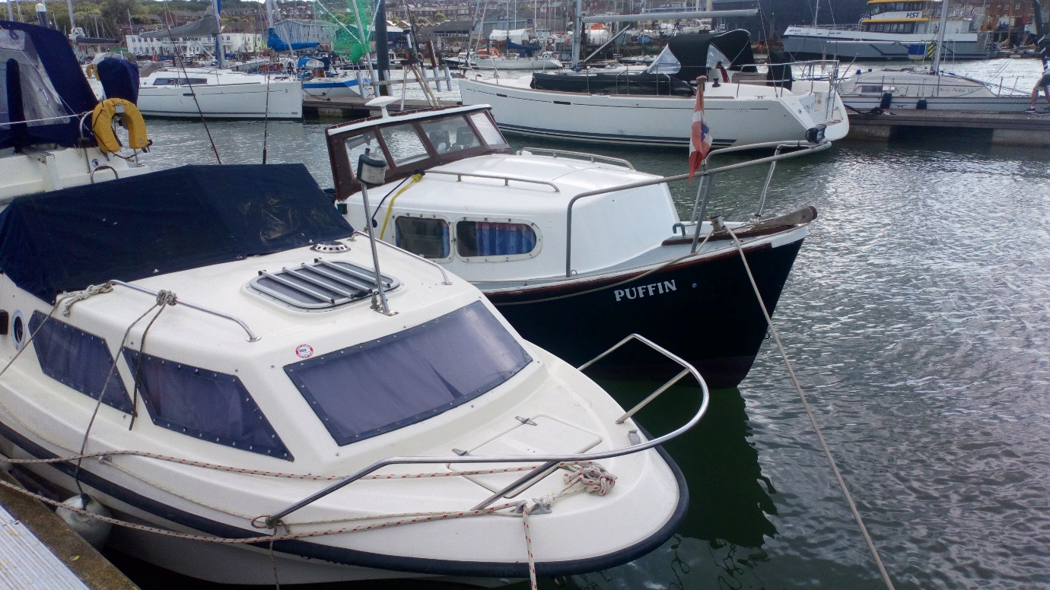

*Number of points are given depending on number of fishermen who have caught the target species, e,g 16 people , 16 points for heaviest fish and 15 for next heaviest etc.

