Report on biggest Ray competition April 18th 2021
What a fantastic turn out for the first competition of the year after lockdown. Fishing was good with six boats; Richard in Puffin with Dan; Dave Abrook in his boat; Mike in Kaikoura with Paul H; Herbie in his boat, Sam in his boat with crew, Brian in his boat.The weather was a brilliant sunny day and boats headed in different directions around the Solent; Ryde middle, Bramble bank, Norris, Kings Quay and Peel Bank.
Fishing started at 8 a.m, a bit slow to start with, but improved as the tide slackened. Kaikoura was greeted by a seal off Kings Quay, but didn’t help with our fishing!
The “weigh in” was at 4 pm, where most fish were returned and it was a matter of trust. Dave Abrook was a clear winner with a thornback of 11lb 7 oz. He also caught a 10lb undulate and a 7llb thornback. He gained 5 points* towards the cup at the end of the year. Other fishermen with rays were Paul H with a Thornback of 7lb 8 0z (4 points); Herbie with a thornback of 5lb (3 points); Brian with a spotted ray of 3lb 4 0z (2 points) and Dan with a spotted ray of 3lb (1 point).
Other fish caught were plenty of dogfish and it was good to see some early smooth hounds caught.
The next competition is another Ray competition on May 16th ,
Cheers Richard and Mike

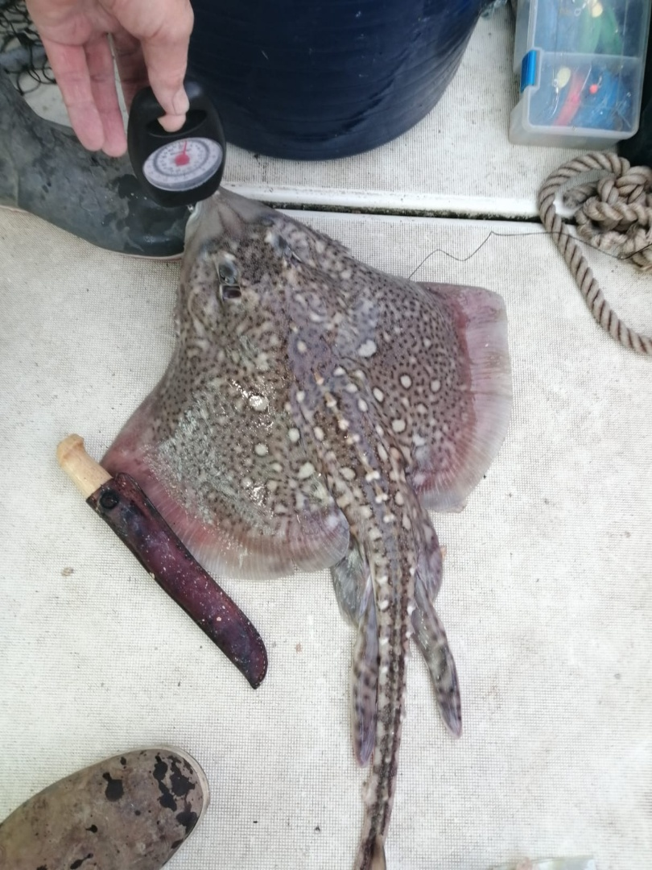
*Number of points are given depending on number of fishermen who have caught the target species, e,g 5 people , 5 points for heaviest fish and 4 for next heaviest etc.

