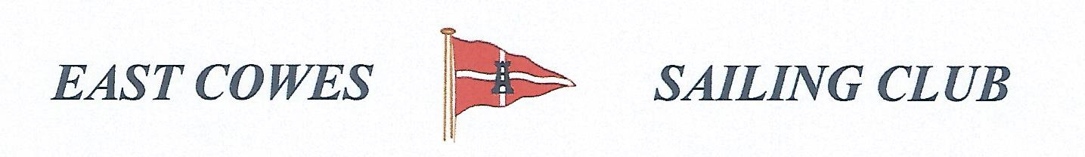 HEAVIEST RAY COMPETITION
SUNDAY 18TH April 2021
Weather Permitting
High Tide 16:00, Low tide 10:00
2 rods per person allowed ; No entrance fee
Start fishing from 0800, Weigh in 16.00 0utside the club house for heaviest Ray.
Covid 19 rules apply . Solitary fishing, or only one crew. Keep hand sanitiser on board
Only meet for 15 mins outside club after at 1m .
Hammer head required evening of 17th April.
For further information contact Richard Davis Rear Commodore Motor Boats & Fishing email: motor@eastcowessc.co.uk Mobile: 07958 629116
Or Mike Harvey 07746 188062
