Report on biggest Cod and Fish competition October 11th 2020
Fishing was good with six boats and eight fishermen; Paul H in his boat, Richard in Puffin; Dave Abrook in his boat; Mike in Kaikoura with Chris; Lee in Womble and Herbie in his boat, with Sam.
The weather was a brilliant sunny day with a choppy sea to start the day.
Half the boats headed for shelter on the North side of the Solent near Calshot and Beaulieu. Paul H stayed near Castle Point, Lee in Womble fished of Ryde Middle and Dave fished off the Bramble.
With no fish caught by coffee time, Mike and Chris ventured back to the Bramble bank close to Dave.
At the end of the day two cod were caught, one of 6lb 4 oz, by Dave and a 3lb codling (see picture) caught by Chris.
Other fish caught on the day were smoothound, dogfish, whiting and congers. Lee and Dave also reported cod being caught by other boats nearby.
Stories were told later of Richard watching Columbo again and Mike and Chris fending off a trimaran, who’s crew needed to go to specsavers!
The next proposed competition will be another Cod and biggest fish competition on the 22nd November. Watch the club web site and gate notice board.
Cheers Richard and Mike
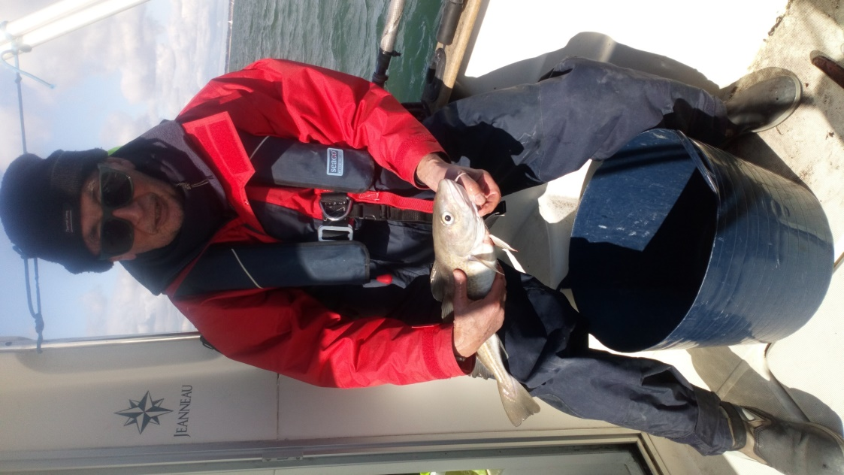
1. Chris Kershaw - Club Secretary

