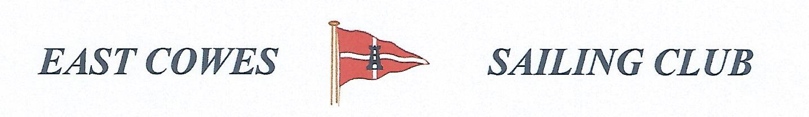 SECOND HEAVIEST FISH AND COD COMPETITION
SUNDAY 22nd November 2020
Weather Permitting
High Tide 1700, Low tide 11:00
1 rod per person allowed ; No entrance fee
Start fishing from 0800, Fishing stops at 15.00. Meet outside the club house after.
Covid 19 rules apply . Solitary fishing, or only one crew. One rod only per person for social distancing . Keep hand sanitiser on board
Only meet for 15 mins outside club after at 1m .
Hammer head required evening of 21st November.
For further information contact Richard Davis Rear Commodore Motor Boats & Fishing email: motor@eastcowessc.co.uk Mobile: 07958 629116
Or Mike Harvey 07746 188062
