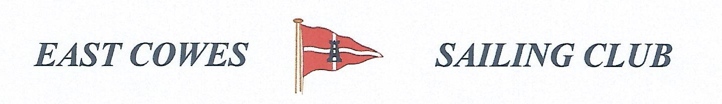 HEAVIEST FISH AND COD COMPETITION
SUNDAY 11th October 2020
Weather Permitting
High Tide 0:645, Low tide 12:00
1 rod per person allowed; No entrance fee
Start fishing from 0800, Weigh in 15.00 outside the club house for heaviest Fish and Cod.
Covid 19 rules apply. Solitary fishing, or only one crew. One rod only per person for social distancing . Keep hand sanitiser on board
Only meet for 15 mins outside club after at 1pm .
Hammerhead required evening of 11th October.
For further information contact Richard Davis Rear Commodore Motor Boats & Fishing email: motor@eastcowessc.co.uk Mobile: 07958 629116
Or Mike Harvey 07746 188062
