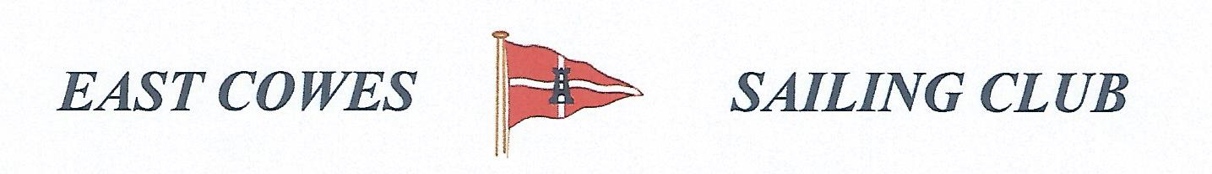
Record of the November Fishing Sub Committee Meeting
Held in the Centenary Room on the 10th March 2020

Present
Mike Harvey – Health and Safety Officer
Richard Davis, Rear Commodore Motor Boats and Fishing
Paul Hippolite
Lee Silk
Paul Masterton
Vince Bowles
Sam Leg
Liam Bryce

Apologies for absence
Bob Spendly
Mark Cook
Ray Hallet

Matters Arising

Discussion from last meeting about revision of fishing rules.
- Introduction of £5 entrance fee
- Competitions for heaviest fish e.g Ray will be for that species only, no heaviest bag. Individuals fishing that day will receive points if they catch a species fish e.g Ray, depending on the weight. E.g if there are 9 people fishing and each person catches a Ray . The heaviest will be 9 points and so on down to the smallest ray, when the individual will receive 1 point. However if there are only three rays caught by there people in the same competition then the maximum number of points will be 3.
- For the spring and autumn species competitions, there will be a maximum of 5 fish allowed per species and different points allocated for each species depending how rare the fish are. The winner will be the one with the most points. However depending on how many fishermen are in the competition the points rolled over will be allocated the same as the other competitions, I,e if five people attend the winner will take 5 points for his total and the person with the least species points will take I point
- Participants in competition must enter their name and crews name on the list in the club house at the start of each competition.
- No heaviest bag, but there will be the option for a sweep amongst individuals. Their choice of the money and type of fish will be up to them.
- Lee will update the rules and Mike will produce a new flyer.
- The next competition on April 11th will be for the heaviest Ray and not the heaviest fish, there will be no heaviest bag for all competitions. Only an optional sweep between individuals.
- Individuals must fish 60% of competitions to qualify for a prize at the Christmas competition at the end of the year and also qualify for the cup.

Fishermans supper on April 11th .
- It was decided to go with fish and chips. Up to 17 fishermen may attend the supper.

Outstanding Actions
None

Completed Actions
All

AOB
The minutes will be added to the fishing web page and the notification of the next meeting will be sent via web collect

Next meeting scheduled for Tuesday 24th March at 19.00

2

