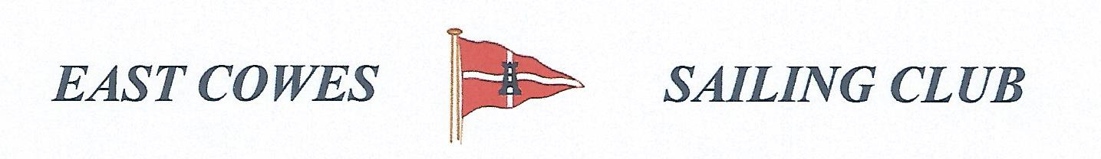
Record of the November Fishing Sub Committee Meeting
Held in the Centenary Room on the 26th February 2020

Present
Mike Harvey – Health and Safety Officer
Richard Davis, Rear Commodore Motor Boats and Fishing
Paul Hippolite
Mark Cook
Lee Silk
Brian Garby?
Ray Hallet

Apologies for absence
Paul Masterton
Bob Spendly

Matters Arising

Feedback from Cod competition in January
Dave Avebrook won the competition with a cod. He should get the Cod trophy which Lee made. (ACTION Richard to contact Dave and sort out trophy)

Discussion about heaviest bag and next competition in April.
This prompted a lengthy discussion and a further meeting in March to discuss the fishing rules.
The following was concluded:
- Introduction of £5 entrance fee
- Proposal to have prize for each person at end of year competition for those who qualify for 6 or more competitions, or members may pay initially for 6 comps i.e £30 if only attending a small number,
- Winner of Largest fish in each competition, adds points over year, (one point per comp). Winner takes larges prize and trophy at end of year.
- Participants in competition must enter their name and crews name on the list in the club house at the start of each competition. Option to enter heaviest bag with another boat (put S after name on form).
- The whole purpose of having the heaviest bag in the first place was to enable those fishermen who wanted to get something out of the competition who were unable to get the target heaviest fish, e.g heaviest smoothound. So should the heaviest bag be for all fish except the heaviest fish, assuming a limit of 5 fish per species? The winner of the heaviest fish may also be the winner of the heaviest bag, but they will be different fish.
- Lee will provide copies of the fishing rules to be discussed at the March meeting. We may have to edit the content of the fishing competitions this year, but not change the dates, (ACTION Lee to bring copies of the rules to discuss at the next meeting),

Fishermans supper on April 11th .
It was decided to go with fish and chips. Up to 17 fishermen may attend the supper. (ACTION Mike to contact Paul and Linda about numbers and menu choice).

Outstanding Actions
None

Completed Actions

AOB
The agenda was sent via web collect so all members should have received this. Mark said he didn’t receive it.

Next meeting scheduled for Wednesday 11th March at 19.00

2

