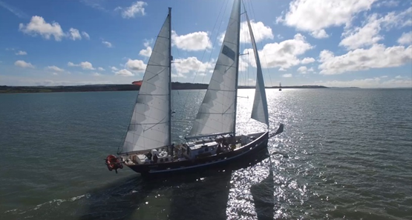

Isle of Wight Support Group

Amazing Offer for Ten Young People from the Isle of Wight – Could some be from your Sailing Club?

Nominate a young person for an amazing FULLY SPONSORED voyage
Following a highly successful pilot scheme in October 2019, and with enormous thanks to many kind supporters on the Isle of Wight and the fundraising efforts of Ocean Youth Trust South's Island Support group, we are delighted to offer ten young people (aged from 12 to 18) from the Isle of Wight the opportunity to participate in one of two 4 night voyages on board the sail training vessel Prolific on either 15-19 April (5 berths) or 23-27 October (5 berths).
The voyages would normally cost around £400 per person but due to the generosity of OYT South's Island Support Group, places are now available completely FULLY SPONSORED (ie; at no cost to those selected) - but HURRY as the places might go quite quickly. Applicants need to live on the island and aged between 12 to 18.
The closing date for applications is 31st January 2020 and it is anticipated that the successful applicants will be notified by the end of February at the latest.

Further Details and Nomination Form: http://www.oytsouth.org/iow_2020.asp
Please bring this attention to any young people in your sailing club who you think might benefit from this exciting opportunity. All you or they need to know can be found on the link above which includes the application form.

The Chairman of the Island Support Group, Brian Mead, said:
“This is a marvellous opportunity for 10 Isle of Wight young people to participate in an exciting and potentially life changing voyage and we are grateful to our generous supporters for making the funds available to fully sponsor them”.

Jodi – a crew member - said: “This was way beyond anything I could imagine and has touched my life in so many different aspects; and for that I cannot thank you enough”.

