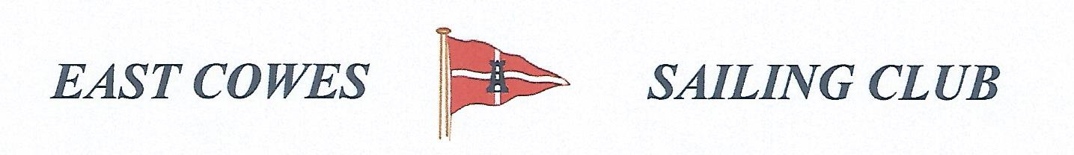 WINTER COD COMPETITION
Sunday 1st December 2019
Weather Permitting
High Tide 14.00, Low tide 0800
2 rods per person allowed ; No entrance fee
Start fishing 0800, Prize awarded at 16.00 at the club house for heaviest cod, and sweep of £2 for those interested for heaviest bag.
Hammer head required evening of 30th November and 1st December .

Affiliated club members welcome
For further information contact Richard Davis Rear Commodore Motor Boats & Fishing email: motor@eastcowessc.co.uk Mobile: 07958 629116
Or Mike Harvey 07746 188062

