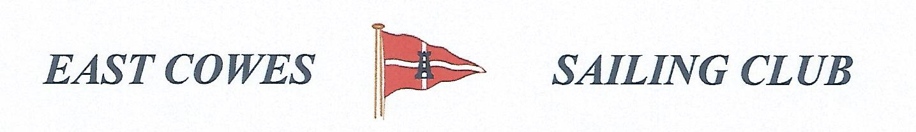 WINTER COD COMPETITION
Sunday 10th November 2019
Weather Permitting
High Tide 10.00, Low tide 15:00
2 rods per person allowed ; No entrance fee
Start fishing 0800, Prize awarded at 16.00 at the club house for heaviest cod, and sweep of £2 for those interested for heaviest bag.
Hammer head required evening of 10th November.

Affiliated club members welcome
For further information contact Richard Davis Rear Commodore Motor Boats & Fishing email: motor@eastcowessc.co.uk Mobile: 07958 629116
Or Mike Harvey 07746 188062

