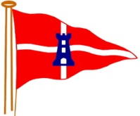East Cowes Sailing Club
Prize Giving Supper
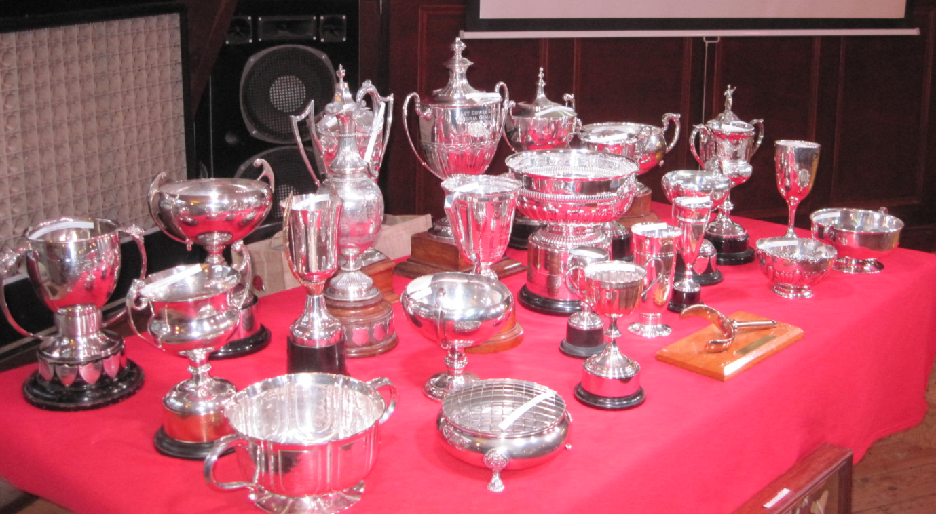
Saturday 26 October 2019
7 pm (Drinks from 6.30pm)
Osborne Golf Club
Menu choices: Roast Gammon; Hunters Chicken, or Vegetarian Macaroni Cheese (to be ordered on booking) plus Chocolate Brownie Desert. Full bar available.
Tickets now on sale through Webcollect, £20.00 per person.
Booking will close on 13 October!
All welcome. Dress smart casual.
Note: No dogs, please. Only drinks purchased at the bar allowed.

