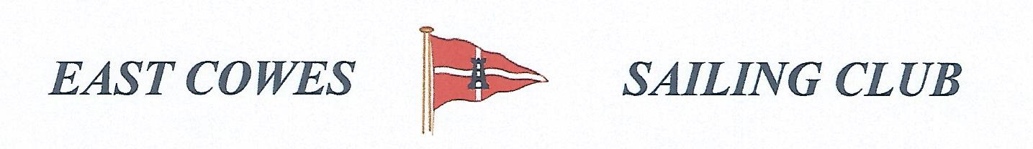
Record of the September Fishing Sub Committee Meeting
Held in the Centenary Room on the 25th September 2019

Present
Mike Harvey – Health and Safety Officer
Paul Masterton

Apologies for absence
Daniel Wirdnam
Richard Davis, Rear Commodore Motor Boats and Fishing
Mark Cook
Paul Hipolite
Bob Spendly

Matters Arising

Feedback from Species Hunt competition
Very successful and well attended.

Fishing Risk Assessment
Mike will mention these at the next ECSC committee meeting in October.

Heaviest Cod and Fish 20th October.
It was agreed that the prizes will be vouchers; Heaviest Cod £20 and Heaviest fish £15. A sweep of £2 a head will be awarded for the heavies bag (only fish taken for the Table, not including dogfish) If no cod are caught then the prize for the heaviest fish will still be £15 and the prize money will be carried over to the next competition in December.

Trip to Bramble bank to watch cricket
Mike and Paul H , went out for this and did some fishing after. There was no competition.

Bait Freezer
This has now been purchased and is in the top of the central store. Mike is awaiting delivery of 20 boxes to hold bait, which the club has agreed to be pay for (about £69). The bait boxes will be advertised in the fishing section on the web site and individuals will pay an annual rent of £3 per year.

Barneys Cup
Richard has spoken to John about inscribing the cup. This will be awarded annually for the winner of the mackerel competition. Judy has won it this year.

Outstanding Actions
None

Completed Actions

AOB
- Paul suggested next year we should include juniors in one or more of the competitions, e.g Mackerel
- It was agreed next year we should have competitions more often, e.g monthly from May to December, also include heaviest bag in most of these, and have a river competition if the weather is too bad to go in the solent.

Next meeting scheduled for Wednesday 23rd October at 19.00

2

