Report on Mackerel Fishing competition and BBQ on July 28^{h} 2019
A record of six boats and 16 fishermen managed to get out for the third competition of the year for the longest Mackerel. There was even a late entry from a sailing couple who wanted to fish in their sailing boat!
The weather was sunny and a bit blustery with a force four of the bramble bank. Fishing marks ranged from Osbourne Bay to Gurnard and North of the bramble bank.
I think all boats caught mackerel except my boat, even the sailing boat caught three and a garfish.
However the star prize was won by Judy in Bob’s boat Dirty Girty III, of 13 inches in length or 33.02 cm. Richard awarded her a £10 prize, kindly donated by the East Cowes tackle shop. She will also be awarded, for one year, the Barneys cup at the Autumn prize giving.
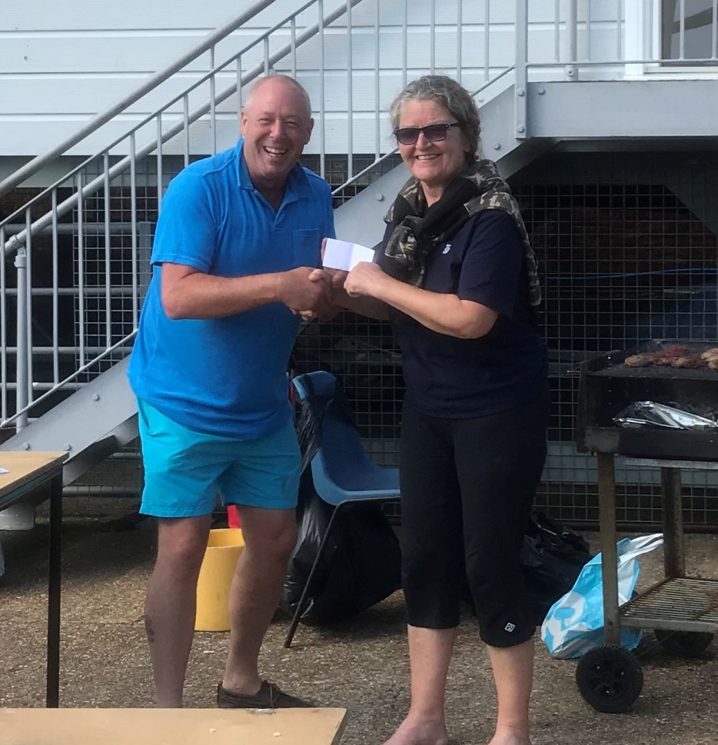
1. Rear Commodore Richard presenting the prize to Judy from Dirty Girty III
The BBQ was also well attended with additional members from the club joining in. Sausages, burgers and mackerel were enjoyed by all.
One ending point of interest is that the sailing boat participating was asking me if I had heard of any fishing boats for sale……

Cheers Richard and Mike

