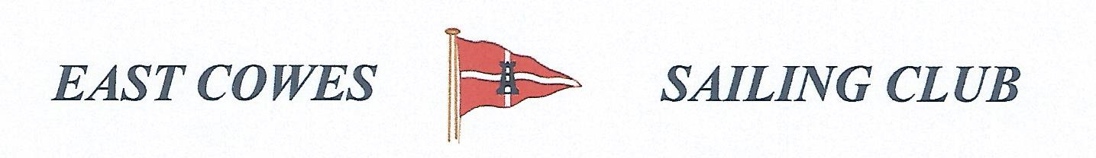 FISHING COMPETITION FOR BIGGEST RAY
Sunday 28th April 2019
Weather Permitting
High Tide 0700, 2000 Low Tide 12.00 PM
2 rods per person allowed; £5 entry per person.
Fishing starts from 0700 and prizes awarded at 18.00 at the club house for heaviest Ray. If released, fish weighed on boat and preferably photo taken.
Affiliated club members welcome
For further information contact Richard Davis Rear Commodore Motor Boats & Fishing – email motor@eastcowessc.co.uk Mobile 07958 629116;
Or Mike Harvey 07746188062; Dave Bonham 07975898227

