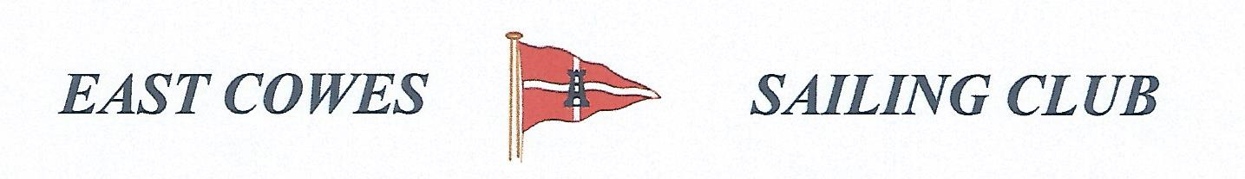 WINTER FREEZE UP BIGGEST COD OR RIVER FISH
Sunday 13th January 2019
Weather Permitting
High Tide 1700 PM Low Tide 09.30 AM
2 rods per person allowed; £5 entry per person.
Hammer head required for boats on evening of 12th January
Fishing starts from 0700 and prizes awarded at 17.00 at the club house for heaviest Cod
Alternate comp if weather is bad to fish River Medina for the biggest flounder.
Affiliated club members welcome
For further information contact Richard Davis Rear Commodore Motor Boats & Fishing – email motor@eastcowessc.co.uk Mobile 07958 629116;
Or Mike Harvey 07746188062; Dave Bonham 07975898227

