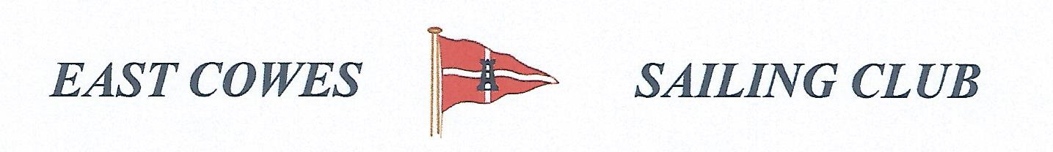 HEAVIEST COD AND HEAVIEST WHITING COMPETITION
Sunday 18th November 2018
Weather Permitting
High Tide 0800 AM Low Tide 13.00 PM
2 rods per person allowed; £5 entry per person.
Hammer head required for boats on evening of 18th November.
Prizes awarded at 17.00 at the club house for heaviest Cod and heaviest whiting
Affiliated club members welcome
For further information contact Richard Davis Rear Commodore Motor Boats & Fishing – email motor@eastcowessc.co.uk Mobile 07958 629116;
Or Mike Harvey 07746188062; Dave Bonham 07975898227
