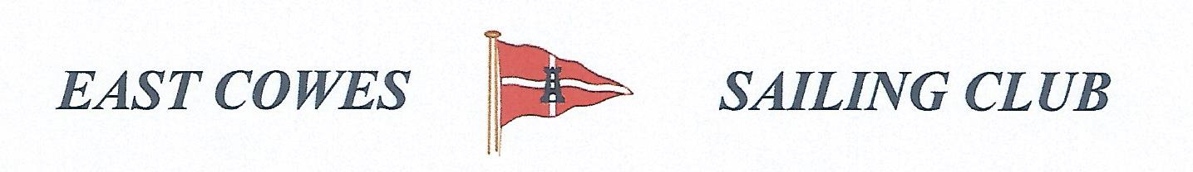 HEAVIEST COD AND HEAVIEST WHITING COMPETITION AND PARTY
Sunday 2nd December 2018
Weather Permitting
High Tide 0700 AM Low Tide 13.00 PM
2 rods per person allowed; £5 entry per person.
Hammer head required for boats on evening of 2nd December
Fishing starts from 0700 and prizes awarded at 16.30 at the club house for heaviest Cod and heaviest whiting
End of year party starts at 17.00 hours in the club house . This will be held even if fishing is cancelled.Bring your own drinks and food. All ECSC members welcome.
Affiliated club members welcome
For further information contact Richard Davis Rear Commodore Motor Boats & Fishing – email motor@eastcowessc.co.uk Mobile 07958 629116;
Or Mike Harvey 07746188062; Dave Bonham 07975898227

