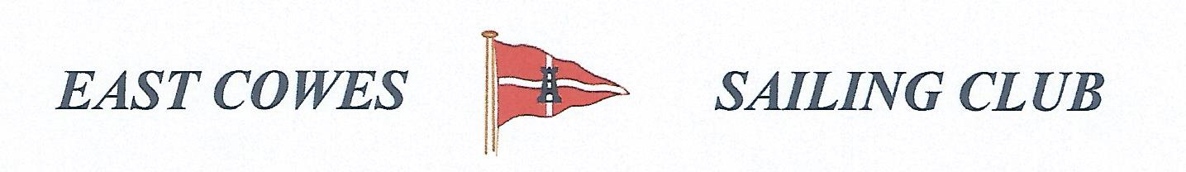 HEAVIEST COD COMPETITION
Sunday 21st October 2018
Weather Permitting
High Tide 10.27 AM Low Tide 15.30PM
1 rod per person allowed; £5 entry per person.
Hammer head required for boats on evening of 21st October.
Prize awarded at 18.00 at the club house FOR Heaviest Cod
Affiliated club members welcome
For further information contact Richard Davis Rear Commodore Motor Boats & Fishing – email motor@eastcowessc.co.uk Mobile 07958 629116;
Or Mike Harvey 07746188062; Dave Bonham 07975898227

