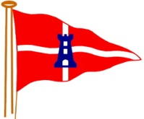East Cowes Sailing Club
Race to Lymington
for Marlowe Cup
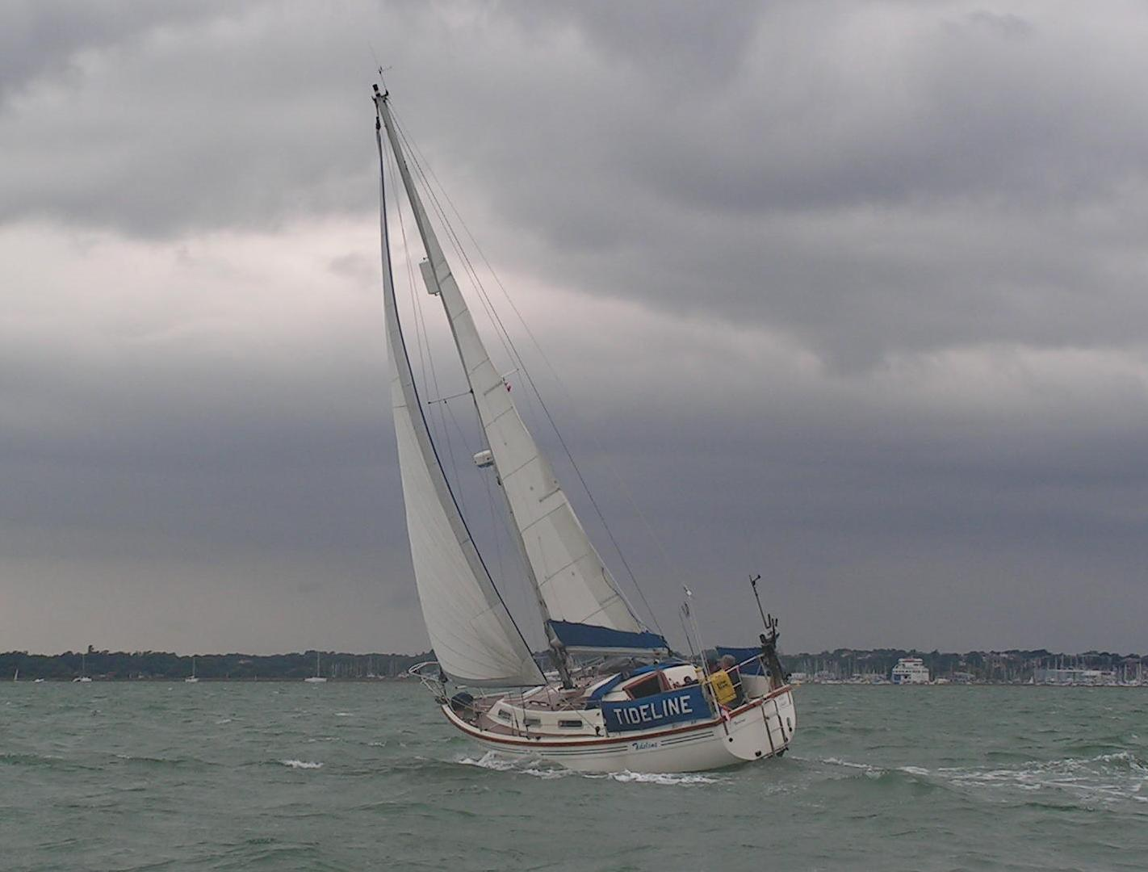
Saturday 19 May 2018
Start at Shrape Line at 1300 b.s.t.
Entries to RC Sailing by 17 May 2018
Sailing Instructions with Course available on
Friday 18 May 2018
No pre-booked block berthing
Individual boats make own arrangements.

